Behavioural Architect Resource List
COM-B
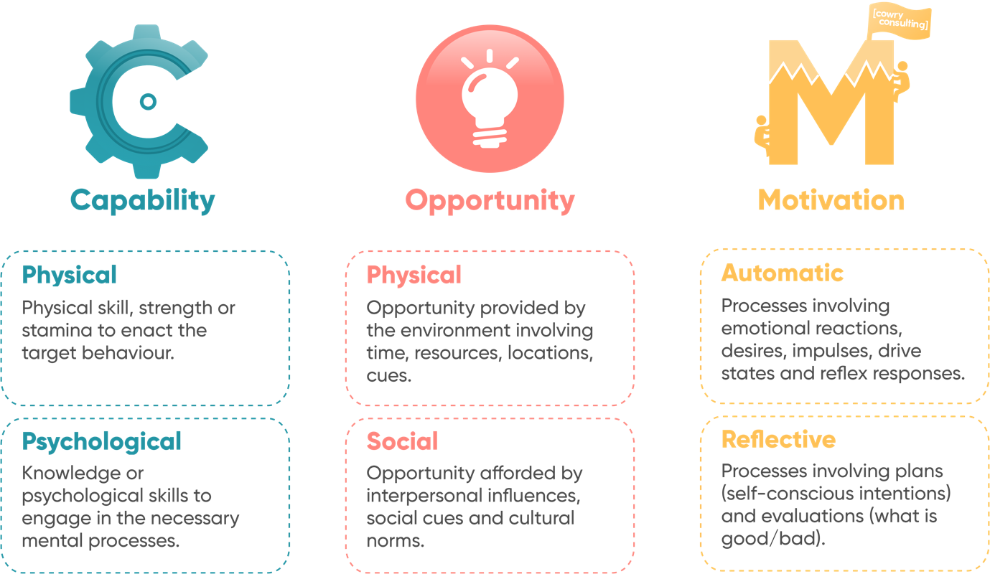

COM-B is a popular behaviour change model designed by Susan Michie and colleagues from the University College London.
The components of the COM-B Model intact as follows:
- C and O often interact to influence M.
- C, O, M influence Behaviour (B) together.
- Behaviour influences these three components too which creates a feedback loop that leads to long term behaviour.
Successful interventions will change one or more of these components in a way that maximises the new behaviour and reduces risk of old behaviours being repeated.
Link to the full article: https://www.ncbi.nlm.nih.gov/pmc/articles/PMC3096582/

MINDSPACE
MINDSPACE is a useful framework created by the Behavioural Insights Team which distils a number of biases and heuristics into 9 overarching principles. These principles can be useful for thinking about what interventions could be applied to different contexts.
These overarching principles include:

- Messenger: We are heavily influenced by who communicates information to us
- Incentives: Responses to incentives are shaped by predictable mental shortcuts
- Norms: We tend to follow what those around us are already doing
- Defaults: We “go with the flow” of pre-set options that are offered to us
- Saliency: Our behaviour is greatly influenced by what our attention is drawn to
- Priming: People behave differently if they have been “primed” by certain cues
- Affect: Emotional associations can powerfully shape out actions
- Commitment: We seek to be consistent with our public promises, and reciprocate acts
- Ego: We act in ways that make us feel important and better about ourselves

Link to full article: https://www.bi.team/publications/mindspace/
APEASE Framework
The APEASE framework is a tool which supports practical, effective, and ethical running of behavioural interventions. The framework includes:

- Acceptability: How far is it acceptable to all stakeholders?
- Practicability: Can it be implemented as designed within the indented context, material or human resources?
- Effectiveness: How effective and cost-effective is it in achieving desired objectives in the target population?
- Affordability: How far can it be afforded when delivered at the scale intended?
- Side-Effects: How far does it lead to unintended adverse of beneficial outcomes?
- Equity: How far does it increase or decrease differences between advantaged and disadvantaged sectors of society?

Link to full article: https://www.unlockingbehaviourchange.com/pdfs/5c766be7b6281890464249.pdf

